MSL Recruitment Portal — User Manual

Audience: MSL Admin, MSL Clients, Job Seekers
Purpose: This manual explains how to use the MSL Recruitment Portal (LinkedIn-like interface). It includes step-by-step workflows, UI screenshots placeholders (for proofing), roles & permissions, common tasks, troubleshooting, and a short technical overview (HTML/CSS/JS stack).

Table of contents
Contents
MSL Recruitment Portal — User Manual 1
Table of contents 1
1. Introduction & Key Concepts 2
2. Roles & Permissions (Quick matrix) 3
3. Job Seeker Guide 3
3.1 Login 3
3.2 Dashboard & Top Job Picks 4
3.3 Search & Apply for Jobs 4
3.4 Profile Update 4
3.5 Document Upload & Replace 5
3.6 Notifications & Activity 5
3.7 FAQs & Troubleshooting 5
4. MSL Client Guide 6
4.1 Login 6
4.2 Current Jobs — Overview & Management 6
4.3 Post New Job (Request post job form) 6
4.4 Alerts & Notifications 6
4.5 Invoice Management (View & Print) 7
4.6 Agreements Management 7
4.7 FAQs & Troubleshooting 7
5. MSL Admin Guide 7
5.1 Admin Dashboard Overview 7
5.2 Seekers Management 7
5.3 Clients Management 8
5.4 Current Posted Jobs 8
5.5 Job Invoices & Resume Access 8
5.6 Interview Schedule Management 9
5.7 Logs & Audit Trail 9
6. UI Proofing & Screenshot Guide (for manual proofing) 9
6.1 What to capture 9
6.2 How to take screenshots (Windows) 9
6.3 Annotation 10
6.4 How to attach screenshots to this manual 10
7. Accessibility, Security & Data Privacy Notes 10
8. Technical Overview (HTML / CSS / JS only) 10
9. Release Notes & Versioning 11
10. Appendix 11

1. Introduction & Key Concepts

MSL Recruitment Portal is a lightweight, responsive recruitment platform modeled with a LinkedIn-like UX. It supports three main user types:
- Job Seeker — create or update profile, upload CV/documents, apply to jobs, see personalized job picks.
- MSL Client — company-level users who post jobs, manage applications, view invoices and agreements, and schedule interviews.
- MSL Admin — internal portal administrators who manage seekers, clients, jobs, invoices, and overall moderation.
Key UI metaphors:
- Cards & feeds for job listings and notifications
- Top Job Picks — personalized recommendations using simple matching logic (profile keywords, saved jobs, search & apply history)
- Action buttons (Primary: Apply, Post Job, Schedule Interview)
- Modals for quick forms (apply confirmation, upload documents)

2. Roles & Permissions (Quick matrix)

Feature / Action | Job Seeker | MSL Client | MSL Admin
Login | ✅ | ✅ | ✅
View Jobs | ✅ | ✅ | ✅
Apply to Job | ✅ | — | ✅ (as emulator)
Post Job | — | ✅ | ✅
Manage Applications | — | ✅ | ✅
View Invoices | — | ✅ | ✅
Blacklist Seeker | — | — | ✅
Suspend Client | — | — | ✅
Manage Agreements | — | ✅ | ✅

Permissions are role-based and can be extended via admin settings.

3. Job Seeker Guide

3.1 Login
Path: Home → Sign In → "Job Seeker" tab
Fields: Email / Username, Password. Optional: Sign in with Google.
Flow:
- Enter credentials & click Sign In.
- If 2FA enabled, enter the code sent via email.
- Upon success you land on the Seeker Dashboard.
Errors:
- Invalid credentials → show message: "Email or password incorrect. Forgot password?"
- Account suspended → show support contact.

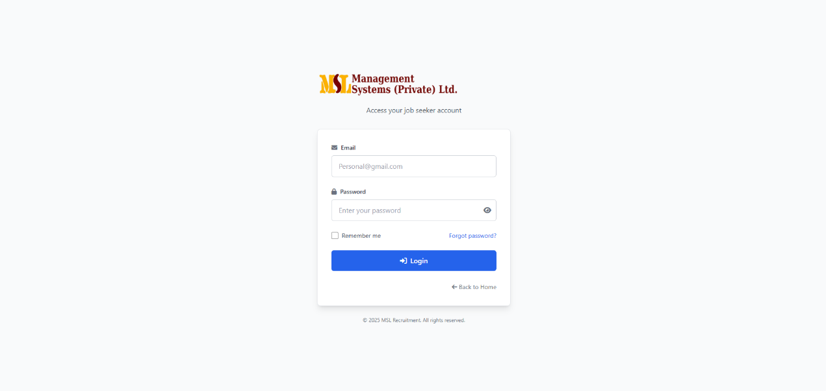
3.2 Dashboard & Top Job Picks
What you'll see:
- Welcome card with quick links (Profile, Documents, Applied Jobs)
- Top Job Picks — a horizontally scrollable list of recommended jobs.
- Recent activity (applies, saved jobs, messages)
How Top Job Picks are chosen (simple explanation for users):
- Matches between your profile skills, location, and job keywords.
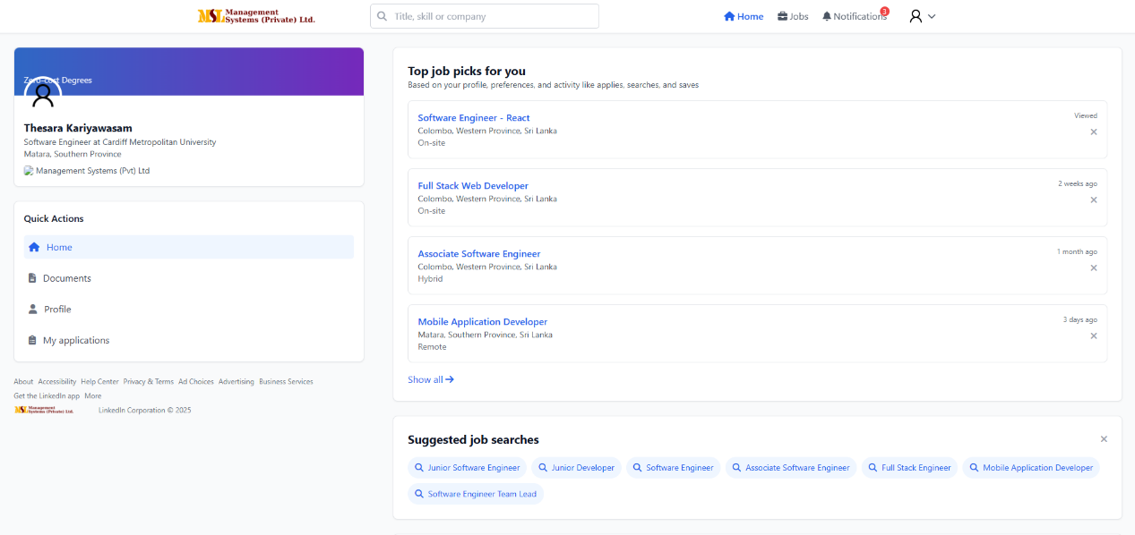
- Your activity (applies, searches, saves) influences rankings.

3.3 Search & Apply for Jobs
Search: Use top search bar — filters: Keyword, Location, Job Type, Sector, Experience level, Salary range.
Apply flow:
- Click job card → open Job Details panel.
- Click Apply → confirm CV/document and add a short message (optional).
- Click Submit Application.
- Confirmation toast and the job move to Applied Jobs.
Notes:
- You can re-open your application to check status.
- If CV access is restricted by the client, the admin or client will unlock it after approval.

3.4 Profile Update
Path: Dashboard → Profile → Edit
Key fields: Full name, Professional headline, Location, Contact details, Experience, Education, Skills, Visibility (Public / Private).
Tips:
- Fill skills as comma-separated tags.
- Keep headline short and specific (e.g., "Clinical Science Liaison — 5 yrs").
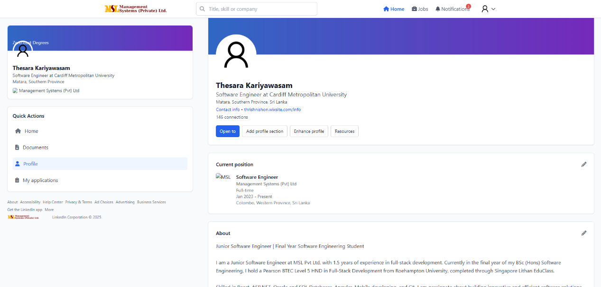
Saving: Click Save. Changes reflect in recommendations within a few minutes (client-side re-index).

3.5 Document Upload & Replace
Path: Profile → Documents
Allowed file types: PDF, DOCX, JPG/PNG (for ID). Max 5 MB per file.
Upload flow:
- Click Upload → choose file → select document type (CV, Cover Letter, Certification, ID).
- Click Upload → success alert.
Replace flow:
- Locate the document in the list → click Replace.
- Upload new file → click Confirm Replace.
Versioning: Previous versions are kept for 30 days (admin settings), with Latest indicated.

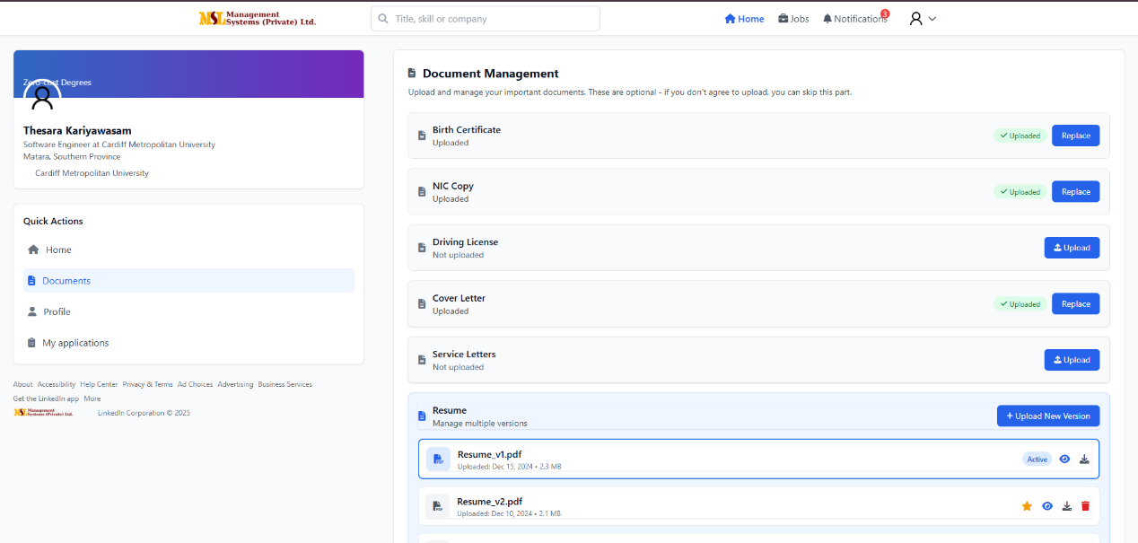
3.6 Notifications & Activity
Common notifications: Application Received, Interview Scheduled, Application Rejected, Message from Client.
Settings: Dashboard → Settings → Notifications (Email / In-app / SMS optional).

3.7 FAQs & Troubleshooting
Q: I uploaded a CV but client can't view it. A: Check invoice/resume access — some clients only get resumes after invoice is paid; contact support.
Q: How do I remove my profile from search? A: Toggle Visibility to Private in Profile settings.
Q: Document failed to upload. A: Check file size and format; try again.

4. MSL Client Guide

4.1 Login
Path: Home → Sign In → "MSL Client" tab
Fields: Company email, password, optional SSO.

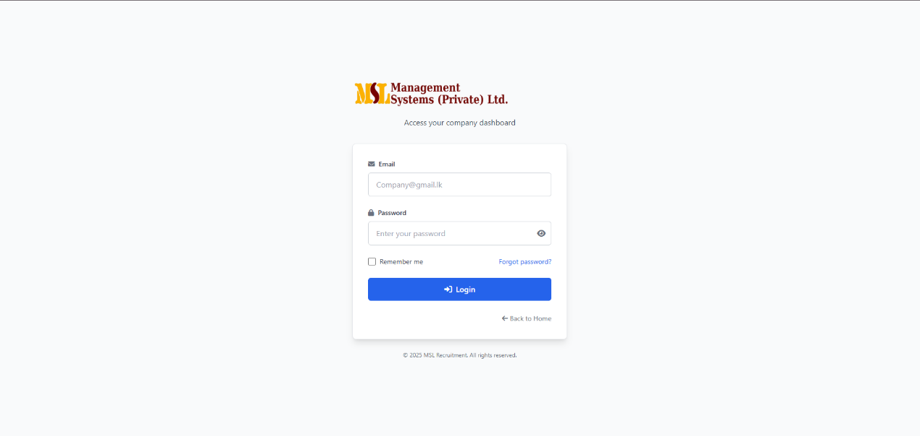
4.2 Current Jobs — Overview & Management
Dashboard widgets: Active Jobs, Total Applications, Scheduled Interviews, Hired This Month.
Current Jobs page shows:
- Job title, Company, Contract & Dates, Applicants (count and quick-view), Invoice Status, Resume Access Status, Actions (Edit, Close, View Applicants).
Actions:
- Edit Job — update description, location, salary.
- View Applicants — opens applicant list (filter by score, experience).
- Schedule Interview — choose date/time and interviewers; candidate receives notification.

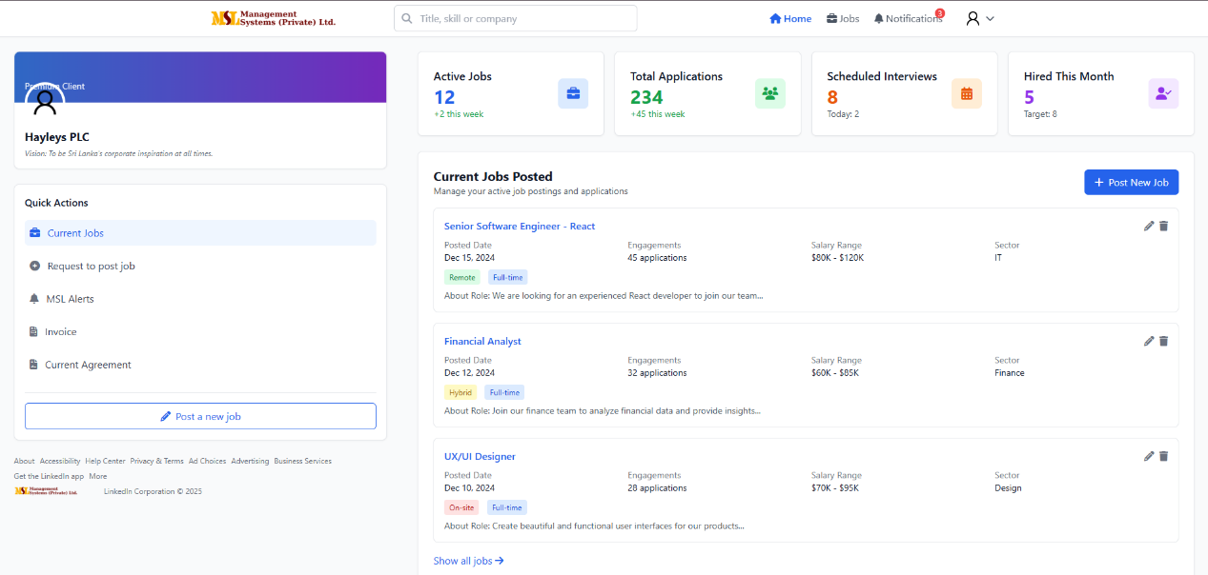

4.3 Post New Job (Request post job form)
Minimal required fields: Job title, Sector, Location, Contract type, Experience required, Salary range, Job description, Application deadline.
Optional fields: Preferred universities, screening questions, assessment links.
Flow:
- Client clicks Post Job → fills request form → submits.
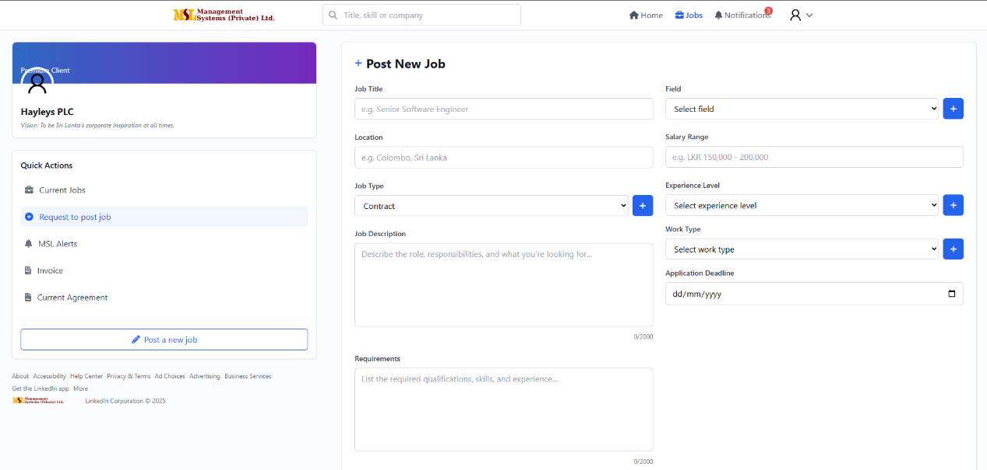
- Job goes to Pending (if admin approval is required) or Active immediately (if auto-publish enabled).

4.4 Alerts & Notifications
Examples: Interview Scheduled, Candidate Confirmed, Scheduled for Today.
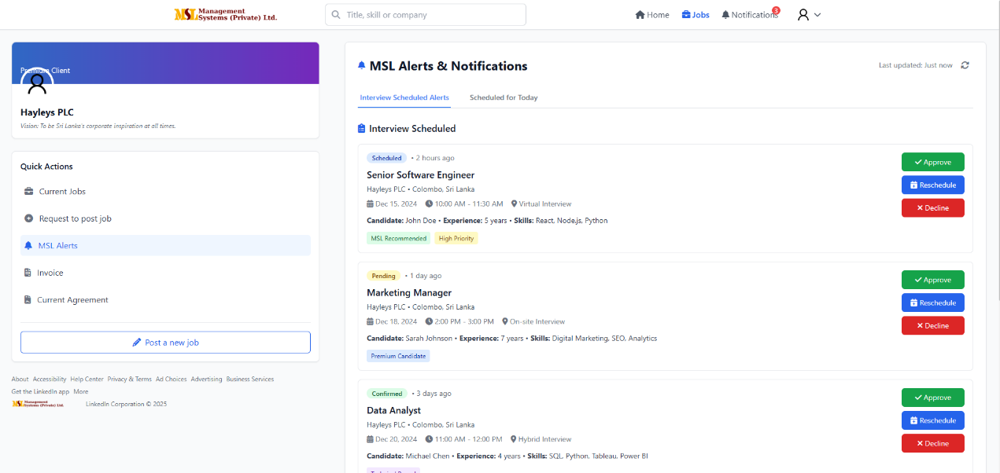
Configuration: Settings → Notifications (Email & In-app). Clients can enable daily digests.
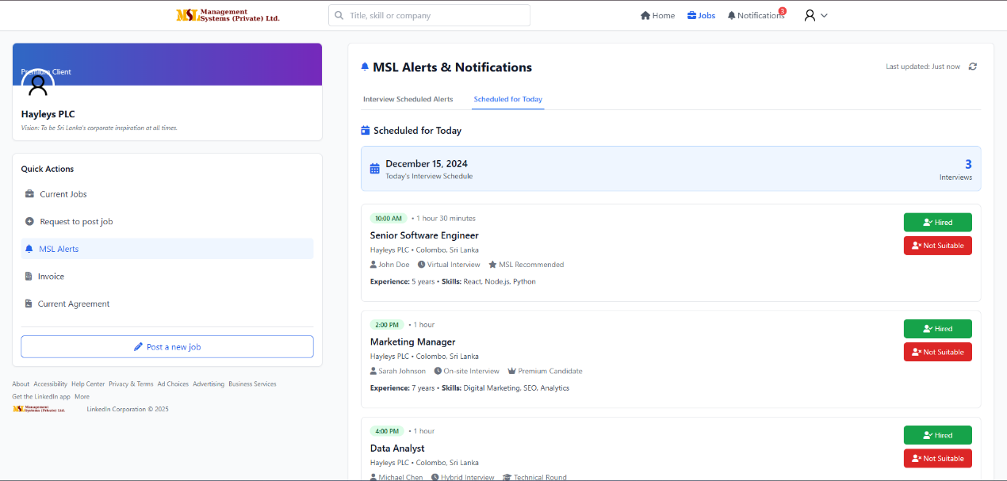

4.5 Invoice Management (View & Print)
Where: Dashboard → Billing → Invoices
View: List of invoices with status (Pending, Paid, Overdue). Click an invoice → view details → Print button.
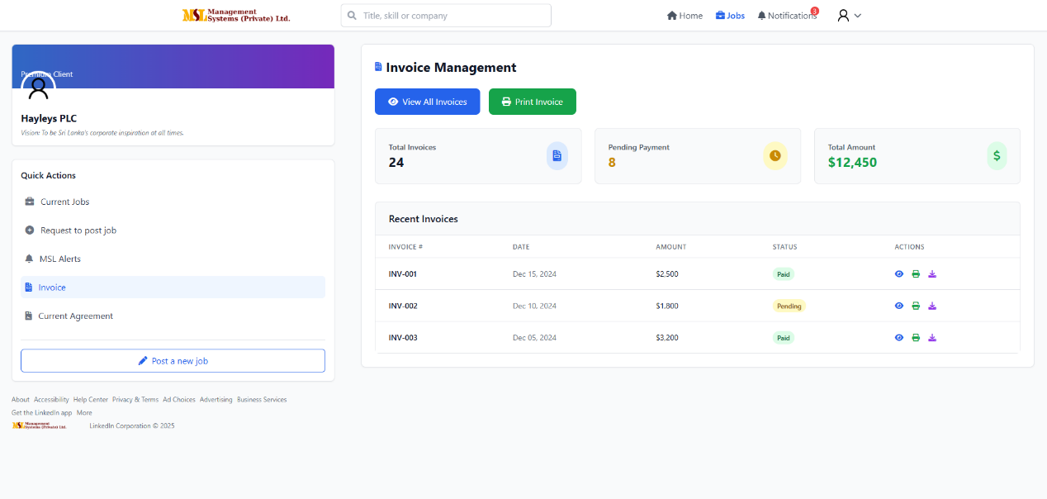

4.6 Agreements Management
Types: Master service agreement (MSL) and Job-specific agreements.
Where: Dashboard → Agreements
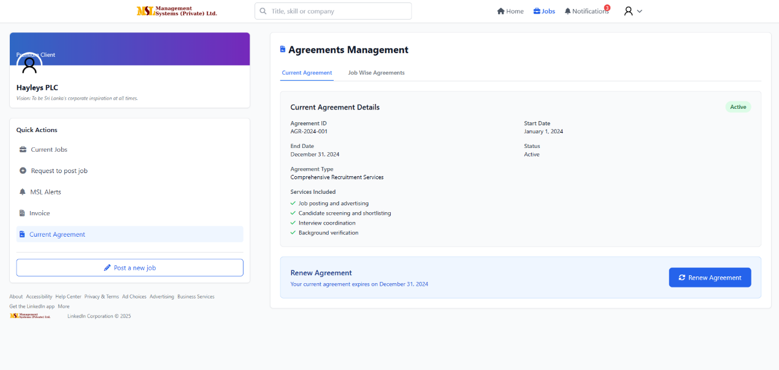
Actions: View, Download, Sign (e-signature), Upload signed copy.

4.7 FAQs & Troubleshooting
Q: How do I get resume access for a job? A: Ensure invoice is paid and resume access toggled on the job's invoice management section or request access from MSL admin.
Q: How to reschedule an interview? A: Go to Scheduled Interviews → select interview → click Reschedule.

5. MSL Admin Guide
Admins have highest privileges. Use responsibly.

5.1 Admin Dashboard Overview
Widgets: Total Seekers, Active Clients, Jobs Posted (live), Today's Interviews, Pending Approvals, System Logs.
Screenshot placeholder:
[Insert screenshot: Admin - Dashboard]

5.2 Seekers Management
Where: Admin → Users → Seekers
Capabilities:
- View profile details (full CV, contact)
- Filter by sector, status (active, inactive, verified, blacklisted)
- Blacklist user — reason required (policy violation, fake profile, spam). Blacklisted users are blocked from applying and flagged to clients.
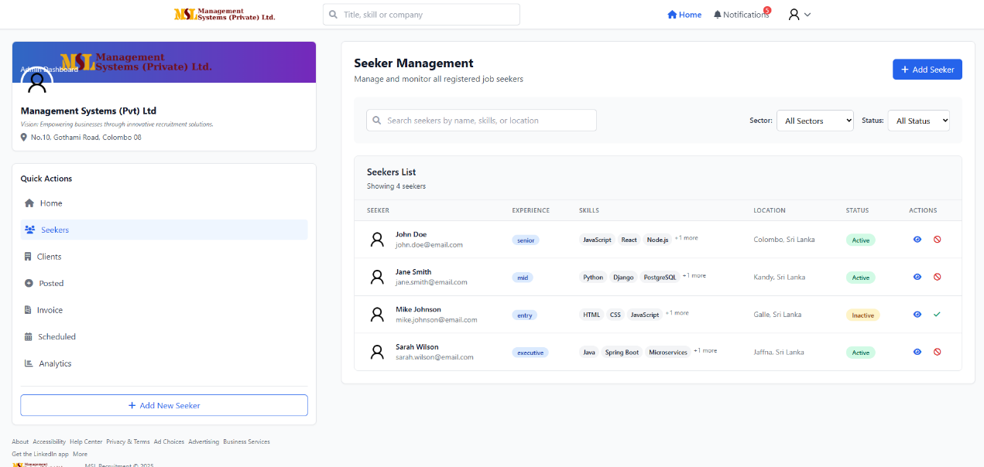
Filter examples: Sector (Clinical, Regulatory), Experience level (Junior/Senior), Verification status.

5.3 Clients Management
Where: Admin → Clients
Capabilities: List clients, open company profile, edit details, suspend company (temporary), permanently deactivate.
When to suspend: Nonpayment, fraudulent behavior, repeated TOS violations.
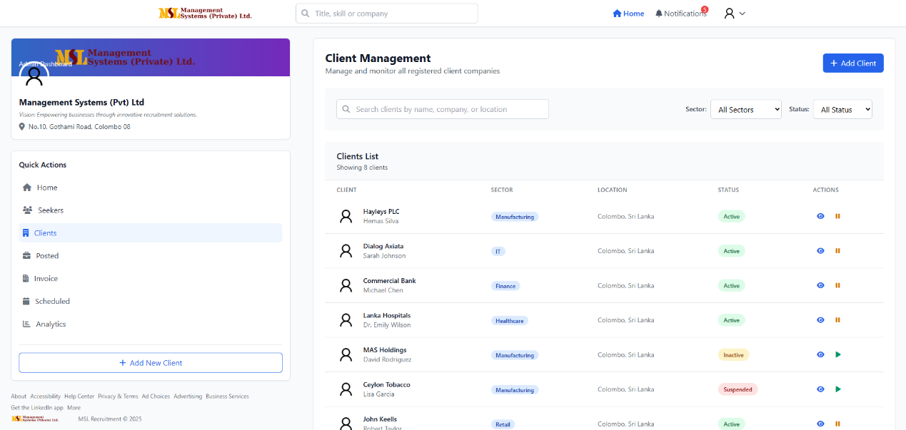

5.4 Current Posted Jobs
Where: Admin → Jobs → Current Posted Jobs
Columns: Company & Job, Contract & Dates, Job Details, Applicants (link to view), Invoice, Status, Actions (Edit, Close, Force-Publish).
Admin actions include:
- Force close job
- Transfer job ownership to another client contact
- Export applicants CSV

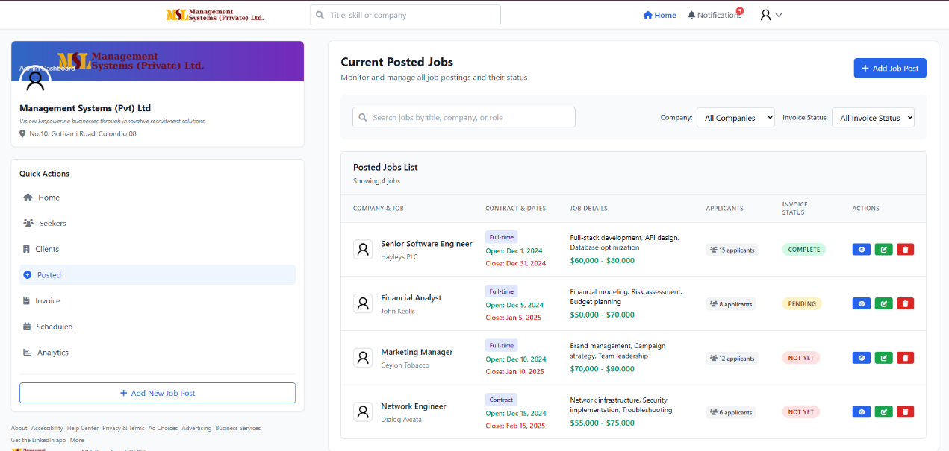
5.5 Job Invoices & Resume Access
Where: Admin → Billing → Current Job Invoices
Columns: Job & Company, Posted Date, Invoice Status, Resume Status, Actions.
Controls:
- Change Invoice Status (Mark Paid)
- Toggle Resume Access: Restricted / Available
- Manually grant resume access to client for specific job
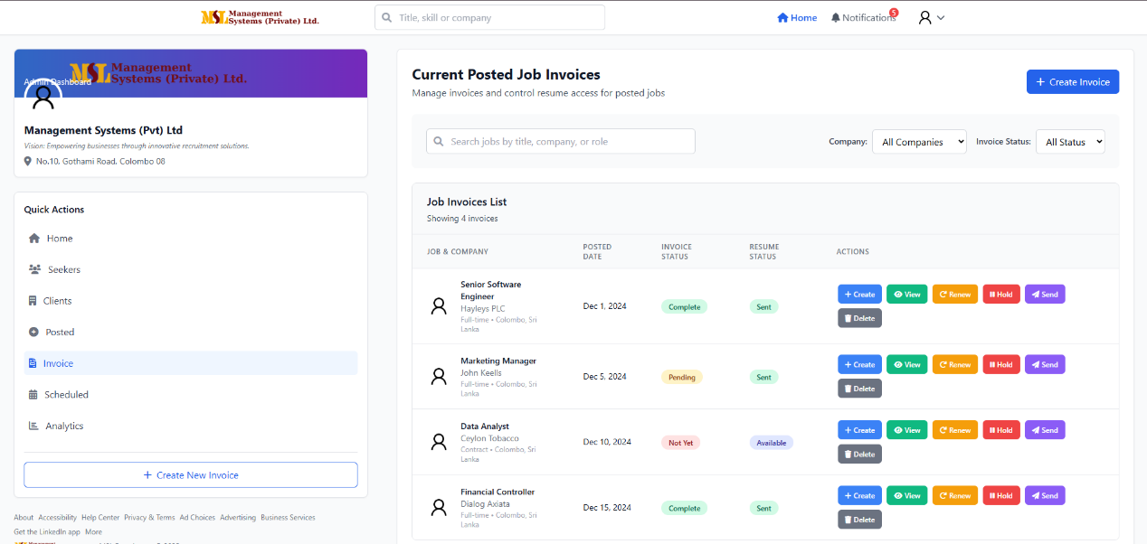

5.6 Interview Schedule Management
Where: Admin → Interviews
Views: Today's Scheduled Interviews, Upcoming, Past.
Actions: Create new interview (choose job, candidate, interviewer(s), location/virtual link), reschedule, cancel.
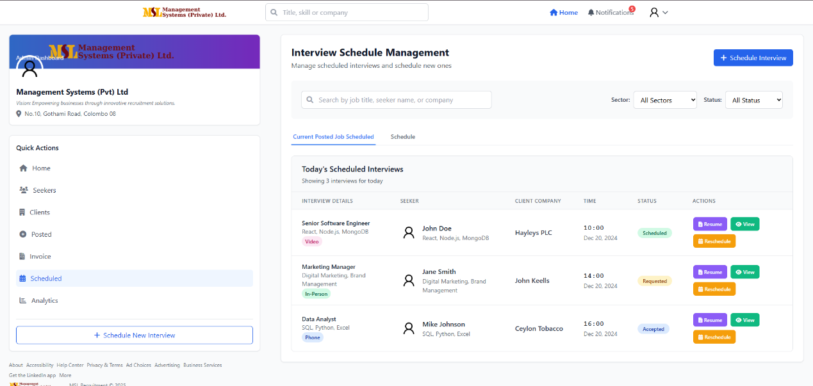
Notifications: Candidates & clients are automatically notified when admin schedules or modifies interviews.
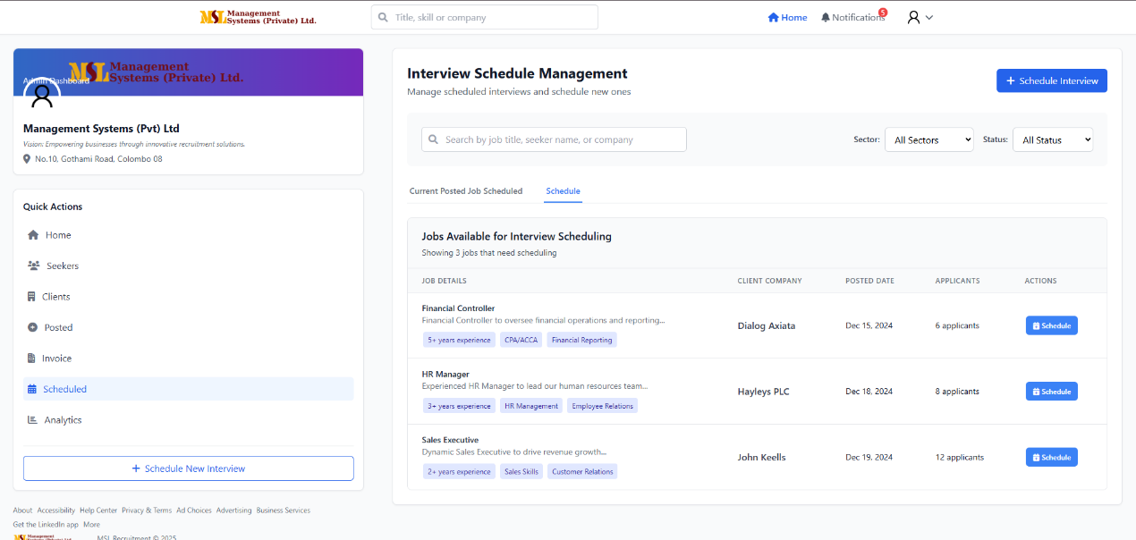

5.7 Logs & Audit Trail
Admins can access audit logs for critical actions: blacklisting, invoice changes, job force-publish, resume access toggles.

6. UI Proofing & Screenshot Guide (for manual proofing)
This section explains how to capture and attach screen images to this manual so anyone can verify UI state and flows.

6.1 What to capture
- Login screens (each role)
- Dashboard for each role
- Example Job Details + Apply flow
- Post Job form (client)
- Invoice print preview
- Admin filters, blacklist flow

6.2 How to take screenshots (Windows)
- Press Win + Shift + S to open Snip & Sketch.
- Select area → paste into an image editor (Paint or Preview) → Save as PNG.
- Name files with pattern: role_page_action_v1.png (e.g., seeker_dashboard_toppicks_v1.png).
Mac: Cmd + Shift + 4 and select area.
Mobile: Use power + volume down (Android) or side button + volume up (iPhone).

6.3 Annotation
- Use a lightweight tool (Paint, Preview, or online: markup) to add arrows and text.
- Use consistent color (e.g., yellow highlight + black text) for clarity.

6.4 How to attach screenshots to this manual
- Preferred: add images to the project folder and reference them in the manual with relative paths.
- For proofing in the portal: Go to Manual → Attachments → Upload screenshots.
- Filename and caption example: seeker_dashboard_toppicks_v1.png — Seeker Dashboard showing top job picks on 2025-09-19.

7. Accessibility, Security & Data Privacy Notes
Accessibility: Ensure semantic HTML, alt text for images, keyboard-focusable interactive elements, and color contrast >= 4.5:1.
Security:
- Use HTTPS across the site.
- Enforce strong passwords and optional 2FA.
- Admin actions should require confirmation modals.
Data retention: Documents and applications stored per policy; previous document versions kept for 30 days by default.
Privacy: Users can request data export or account deletion via Settings → Privacy → Delete Account.

8. Technical Overview (HTML / CSS / JS only)
Stack:
- Frontend: Static HTML pages enhanced with modular CSS (BEM/Tailwind-like) and Vanilla JS (ES6+).
- No backend frameworks included in this manual — integrations are placeholders for REST API endpoints.
Architecture & patterns:
- Single page pattern per role: each role has a main HTML file with modular JS components.
- Components: job-card, profile-editor, upload-widget, modal-dialog, table-list.
- State management: lightweight in-memory JS objects + localStorage for temporary drafts (e.g., unsaved profile edits).
- Forms & validation: client-side validation using HTML5 constraints and JS fallback.
Performance tips:
- Lazy-load images and job list pages.
- Debounce search (300 ms) to reduce filtering cost.
UI parity to LinkedIn:
- Use a 3-column layout for desktop (left nav, center feed, right suggestions).
- Keep interactions lightweight and predictable.

9. Release Notes & Versioning
Maintain changelog entries with the following format: YYYY-MM-DD | vX.Y | Summary.
Example:
- 2025-09-19 | v1.0 | Initial release: Seeker, Client, Admin core flows.

10. Appendix
Sample notification copy
- Application Received: "Thanks, {candidateName}. Your application for {jobTitle} has been received. Status: Submitted."
- Interview Scheduled (Client): "Interview scheduled with {candidateName} for {jobTitle} on {date} at {time}."
Field definitions
- Resume Access: whether a client can view full candidate resumes (controlled by invoice status and admin toggles).
- Invoice Status: Pending, Paid, Overdue.
Error codes (common)
- ERR_UPLOAD_SIZE — file exceeds 5 MB
- ERR_AUTH — auth failure
- ERR_FORBIDDEN — access denied

Next steps & How I can help
- I can add the actual screenshots into this manual if you upload them (I will place them in the correct locations and adjust captions).
- I can export this manual to PDF or a printable format.
- I can generate sample HTML/CSS/JS component templates for the key UI parts (job card, upload widget, admin table).

Document created: MSL Recruitment Portal — User Manual.

